PANOPIO, MARY EMMANUELLE R. 2018110880

2-ECE-C

ECE 2112 | Programming Assignment #8

Experiment 8 – Problem 1

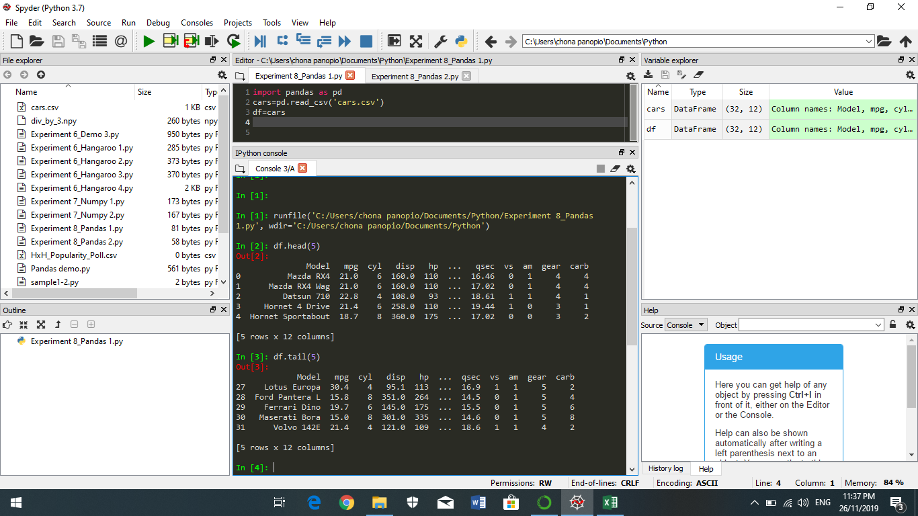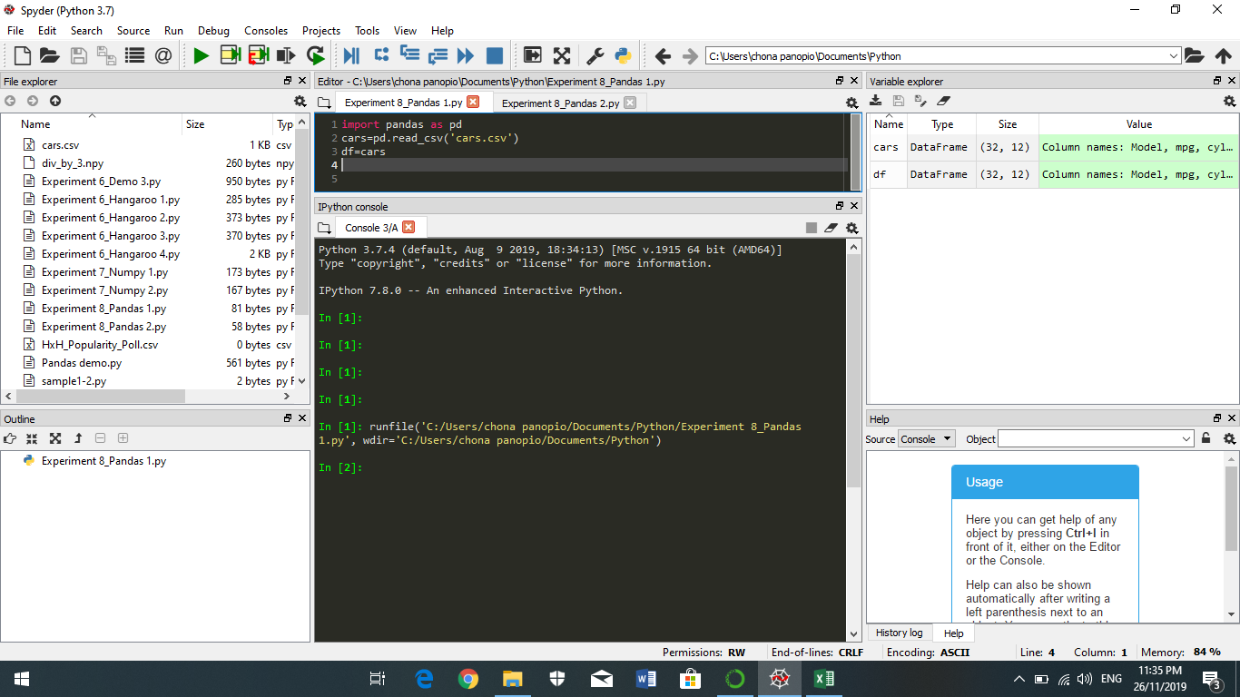

Experiment 8 – Problem 2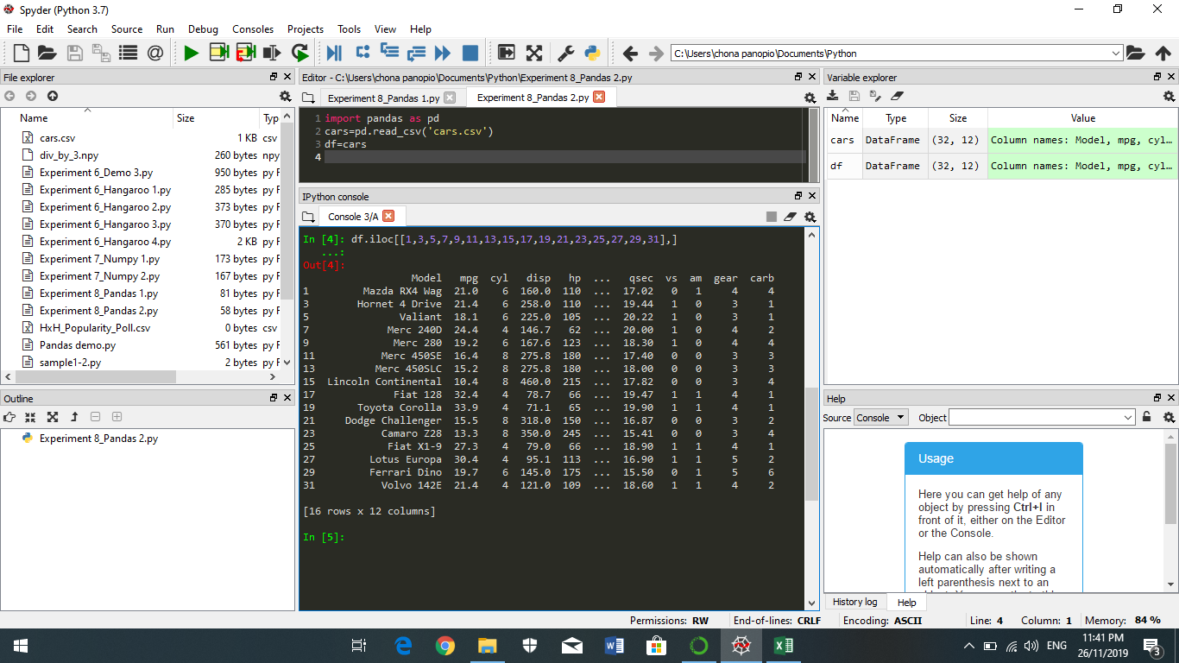

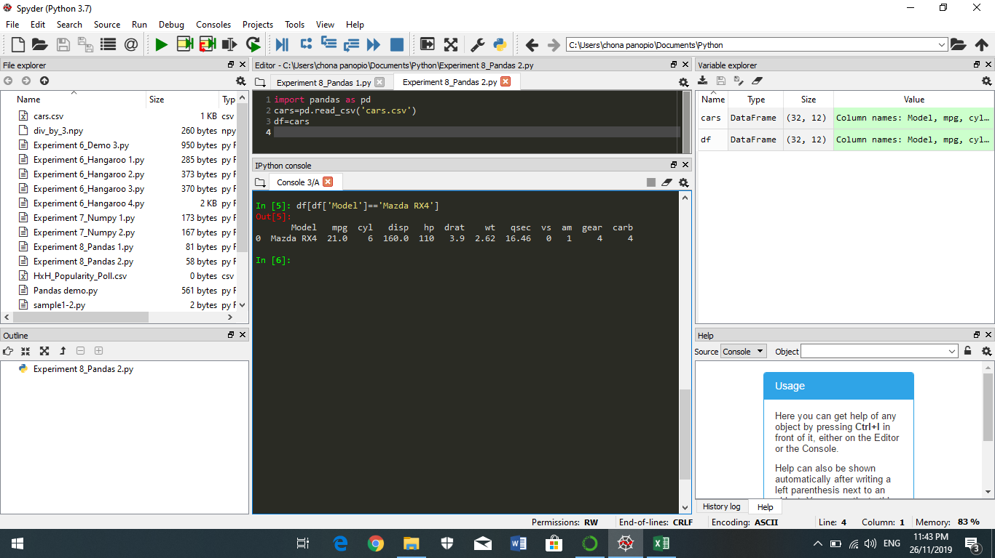

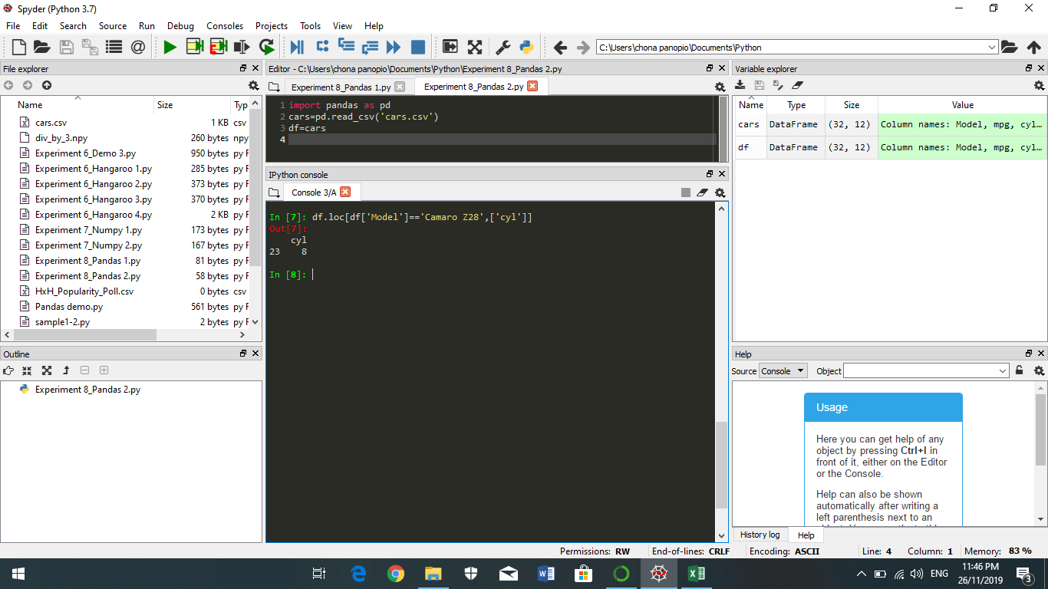

c) Camaro Z28: 8-cylinders

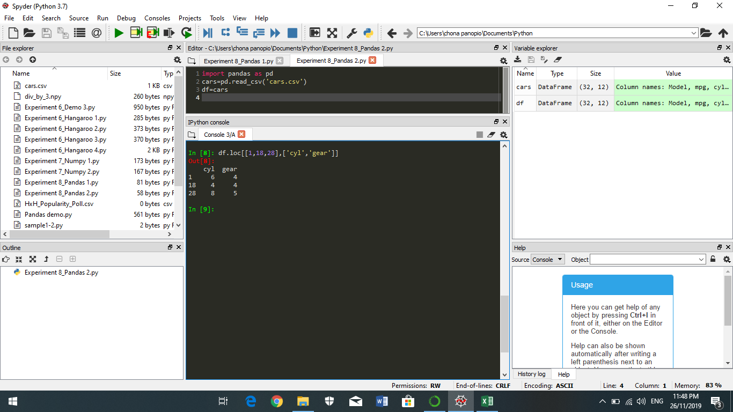

d)

|  |  |  |
| --- | --- | --- |
| Model | Cylinder | Gear Type |
| Mazda RX4 Wag | 6 | 4 |
| Ford Pantera L | 4 | 4 |
| Honda Civic | 8 | 5 |